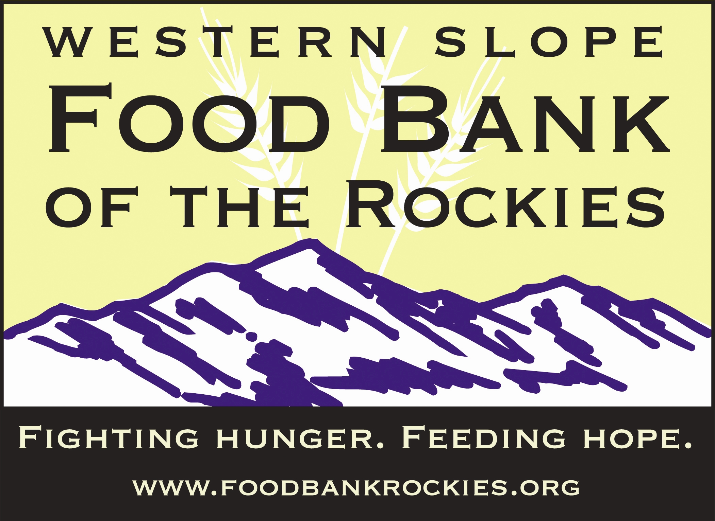

Rules for Online Ordering

- Orders must be submitted according to the requirements on the Header Shortcut Sheet on the next page.
- The food list is updated at the beginning of each week.
- Before submitting your order, you must fill in a pickup date and pickup time or your order will not transmit correctly. Once an order is submitted, no changes can be made online. If you need to make changes, please contact Western Slope Food Bank of the Rockies at 970-464-1138 or westernslope@foodbankrockies.org.
- The pickup times are scheduled every fifteen minutes. Each time slot is limited to a maximum of 2 agencies per time slot. No more than 2 agencies per time slot are allowed. If there are already 2 agencies for a given time slot, you will receive a message saying time not available. You must then select another time slot.
- All correspondence concerning your online order will be via email, so please notify Western Slope Food Bank of the Rockies immediately if your email changes.
- You will be able to confirm your order was placed and have your password emailed to you if you forgot it. If you have additional questions about your online order, check the FAQ below and if you still have questions, contact our Western Slope office, 970-464-1138 westernslope@foodbankrockies.org or our Agency Relations department relations@foodbankrockies.org.
- You can also confirm your order was submitted by clicking “order management”. You will see the recently submitted order with the corresponding PO number at the top. Next to the PO number it will say New Order and later change to Released once we have received the order.
- Limited items will state “MAX= “in the description, noting what the limited quantity is, for example Limit 2 on Diapers would appear DIAPERS ASST (MAX=2).
- The shopping cart total will not reflect grants or credits to be applied toward the order. These will be accurately reflected on your invoice when you pick up your order. For questions concerning your grant or credit balance, contact Starlene at 970-464-1138.

Order Methods:

Pre-pulled orders: for local area programs placing an advance order and picking up at the Western Slope Warehouse. The order must be submitted no less than 24 hours in advance. The order must be over 100 lbs. Orders may be picked up from 8am-1pm M, W, Th, & Fri (or 1-4 pm on Tuesdays.) Please check in with the office prior to loading. Please contact westernslope@foodbankrockies.org or scollins@foodbankrockies.org if you are unable to pick up your order at the scheduled time. No call/no shows – orders will be cancelled, restocked and subject to a $.02 per pound restocking fee.

Delivery: for programs on existing delivery routes placing orders according to a monthly schedule. Orders must be at least 100 lbs. Please refer to the delivery schedule for dates by which orders must be submitted. Date and time in Header should reflect those from the schedule, and delivery instructions should state the city name of the drop site, ex: Yampa Valley Electric, Steamboat Springs.
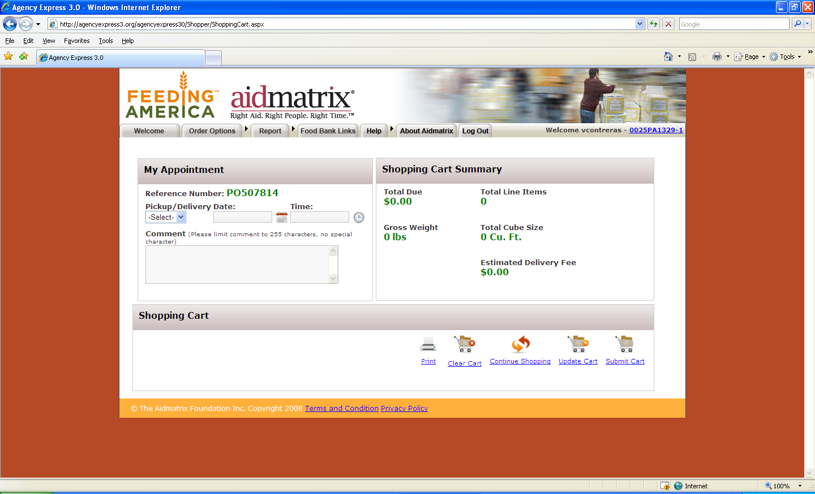
Header Shortcut Sheet

Pre-pulled orders: for local area programs placing an advance order, and picking up at the Western Slope Warehouse. Fill in date, time.

Delivery: for programs on existing delivery routes placing orders according to a monthly schedule. Fill in date, time and instructions: “city name of drop site” in the Comment box.
FAQ Information

Contact Information for questions listed below:
Western Slope: Jill Heidel or Starlene Collins (970-464-1138), westernslope@foodbankrockies.org

I need HELP beyond the information given in the user guide: See contact information above.

How do I get a username, password, and program code? See contact information above.

What do I do if I forgot my username, password, and program code? Click on the Forgot Your Password button on the login page, and follow the steps to receive your password by email.

What steps need to be taken if an Agency Express shopper leaves our agency? Call or email the Western Slope dept listed above and have them remove the shopper that is no longer authorized. WSFBR will need to deactivate the user from using the Online Shopping System on behalf of your program.

How do I update my email address for Agency Express? Call or email the Western Slope dept listed above and give them the correct email address for your username and program code so FBR can update your files.

What do I do if I'm not receiving emails when my order is ready to be picked up at the Food Bank? If you see the order, and the status is “Acknowledged,” yet an email confirmation has not been received, contact the Western Slope office listed above to ensure we have the correct email address. We can then troubleshoot any other errors.

How do I know if my order has changed from the quantities I originally ordered? Confirm the quantities of your order by looking under the Accepted Quantity column under the Order Management tab.

Inventory Limitations - Ordering products with 25 cases or fewer in “Max Order Quantity,” can be limited because of multiple web orders submitted at the same time for the same items. If this occurs continuously, please let agency relations know what the items are for troubleshooting purposes.

Internet Compatibility - Agency Express is compatible with Internet Explorer ONLY, and any other web browser (like Mozilla or Firefox) can cause issues, including the “gray screen,” with the program. You must use Internet Explorer as your web browser when placing orders online.

The order window didn’t get my order - When completing your order, you must go to the “Shopping Cart” tab and select pickup date and time. Then click “Submit Cart.” You will be asked if you are sure you want to submit; click “ok.” Then, your screen will show a new page with a message stating “Your order was submitted successfully.” If you do not see this message, your order was not placed. If you follow all these steps, and the order window still does not get your order, contact Western Slope at westernslope@foodbankrockies.org

Unable to pickup orders or need to cancel an order - Email ASAP to Starlene at scollins@foodbankrockies.org and let her know when you will be able to pick up the order. In most cases, we will be able to accommodate another pick up time. If another pickup time cannot be arranged within reason, the order may be canceled and your program may be charged a restocking fee, at the discretion of Food Bank of the Rockies staff.

Online Ordering Tips

Issue: “Sometimes items are confirmed on our web order, but our program does not receive them, or does not receive the full amount we ordered.”

When online ordering a product with 25 cases or fewer in “Max Order Quantity,” there may be a chance you won’t receive some or all of the items. This is because multiple web orders can be submitted at the same time requesting the same product. If your program orders an item with 25 or more cases available in “Max Order Quantity,” and your program does not receive the full amount of the confirmed order, this should be reported immediately to Starlene at scollins@foodbankrockies.org.

Issue: “When I go into the “Shopping Cart” to review my order, all I see is a tiny square of the screen and everything else is gray!”

Agency Express is compatible with Internet Explorer ONLY, and any other web browser (like Mozilla or Firefox) can cause issues, including the “gray screen,” with the program. You must use Internet Explorer as your web browser when placing orders online.

Issue: “I placed my online order, but now I see a new item I want to add. How can I add it to my order?”

After your order is submitted, you cannot make any changes to it, including adding items. You may place another web order as long as it is done according to the “Rules for Online Ordering”

Issue: “The contact information in the ‘Shopping Cart’ section isn’t correct, and I am not able to change my phone number, fax number, etc.”

Your program cannot make any changes to the Contact section of the “Shopping Cart.” If you need to update information for your program, please contact Jill Heidel at jheidel@foodbankrockies.org

